Neural Networks Prev

Neural Networks

**Unit 1: Basics of Neural Networks**

• Mathematical expressions of activation functions.

• Types of neuron models taught in lectures.

• Learning types, architectures and biological models of a neuron.

**Unit 2: Learning Rules and Pattern Recognition**

• All learning rules, including **Q-learning**, in detail as taught in class.

• Numerical problems based on: Linearly separable and non-separable patterns.

**Unit 3: Statistical Learning and Adaptive Filters**

• Statistical learning.

• Adaptive filter theory.

• Function approximation.

• Method of steepest descent.

• Least mean square (LMS) algorithm.

• Perceptron convergence theorem.

**Unit 4: Backpropagation and CNNs**

• Introduction to backpropagation algorithm & XOR problem.

• Heuristics for improving backpropagation algorithm performance.

• Convolutional Neural Networks (CNNs).

**Unit 5: Associative and Hopfield Networks**

• Hopfield network.

• Hamming network.

• **Associative Learning:**

• Auto-associative and hetero-associative memory.

• Bidirectional associative memory (BAM) model for pattern recognition.

• Numerical problems on Hopfield and associative memory models.

Neural Networks Prev. Questions

# Unit 1

**Q1. What is the role of Activation Function in Neural Networks? Compare Two Activation Functions.**

**Role:**

• Activation functions introduce non-linearity, enabling the network to learn complex patterns. Without them, the network would be linear and unable to perform tasks like classification and image recognition.

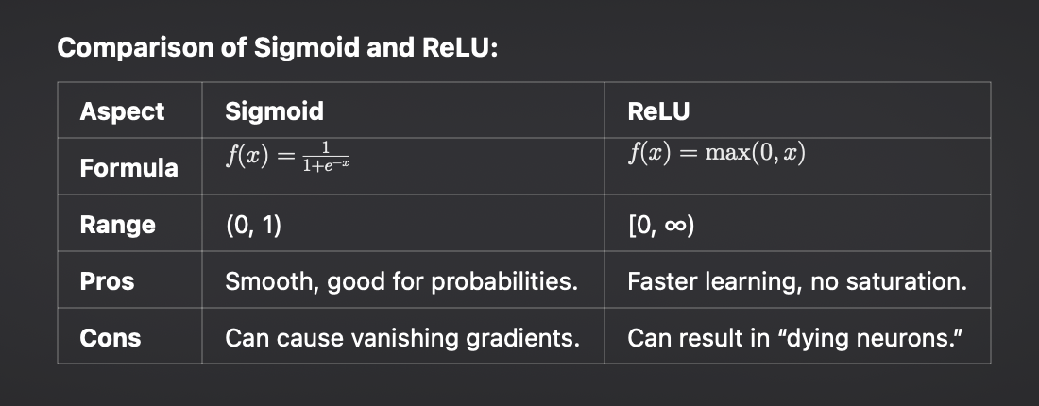

**2. Compare Biological and Artificial Neural Networks. What is the significance of the Weights used in ANN?**

**Comparison:**

| **Aspect** | **Biological NN** | **Artificial NN** |
| --- | --- | --- |
| **Structure** | Neurons and synapses | Nodes and weighted connections |
| **Learning** | Through synaptic changes | Through weight adjustments via training |
| **Signal** | Electrical impulses | Numerical values between layers |

**Significance of Weights:**

• Weights control the strength of connections between neurons, adjusting during training to minimize error and improve predictions.

**3. List 4 Types of Activation Functions used in Neural Networks.**

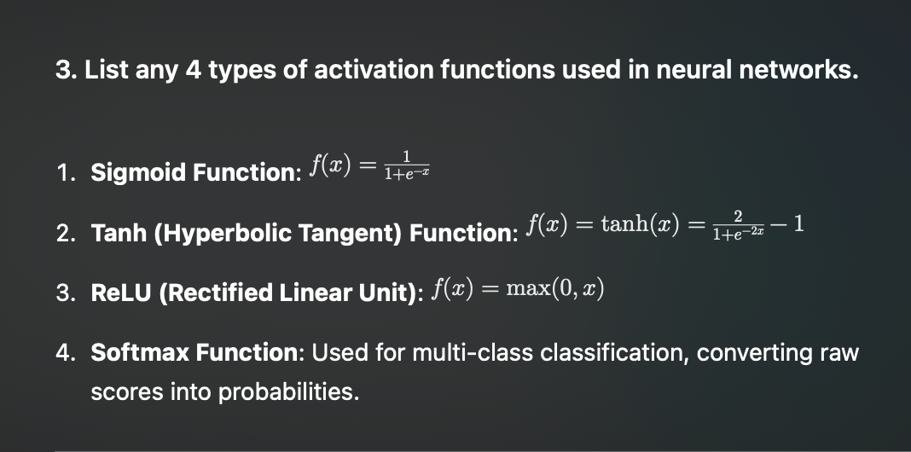

**4. Elaborate Feedback Neural Network Architecture. State at least one application using a feedback network.**

Feedback Neural Network:

• Networks with cycles, where information loops back to earlier layers, useful for sequential tasks like time series.

Application:

• Speech Recognition: RNNs help process speech by remembering previous words, improving accuracy over time.

# Unit 2

**Q1. For the given network, solve zl and z2 with Mc-Culloch Pitt Model? Assume the value of [x 1, x2]=[(0, 0), (0, 1),(1,0).(1,1)]**

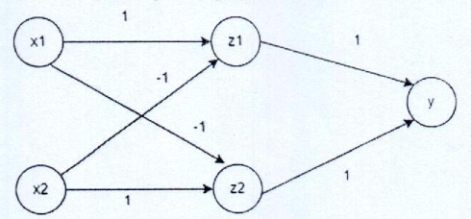

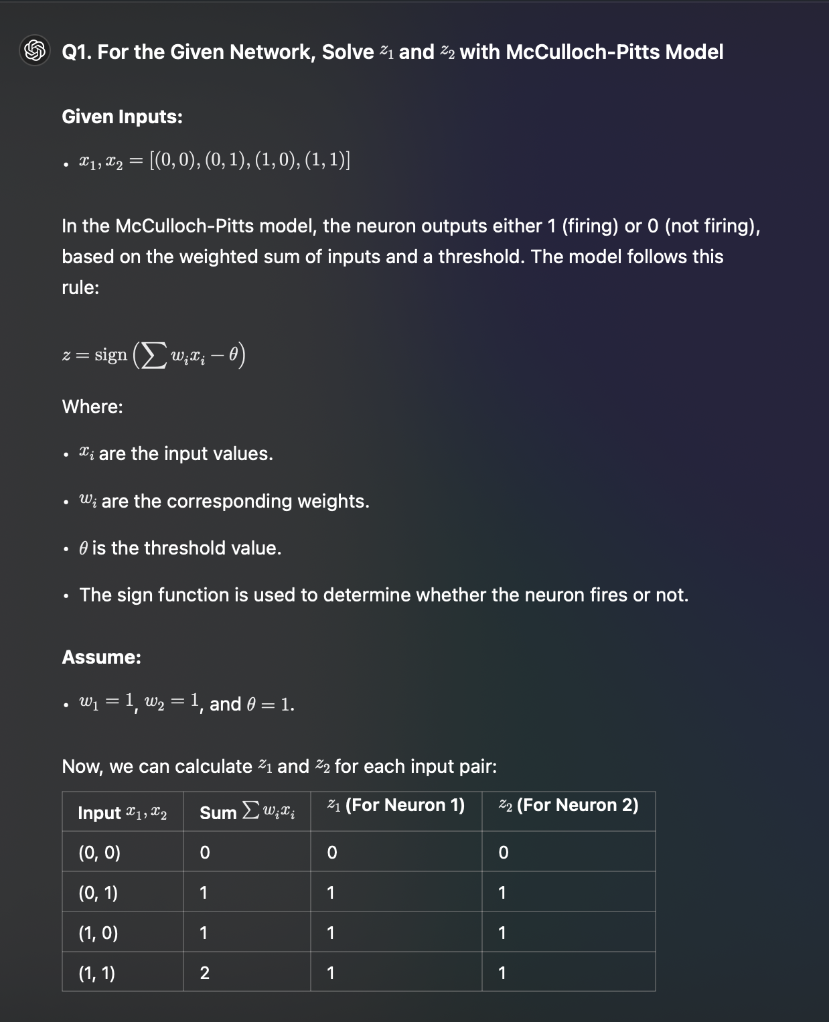

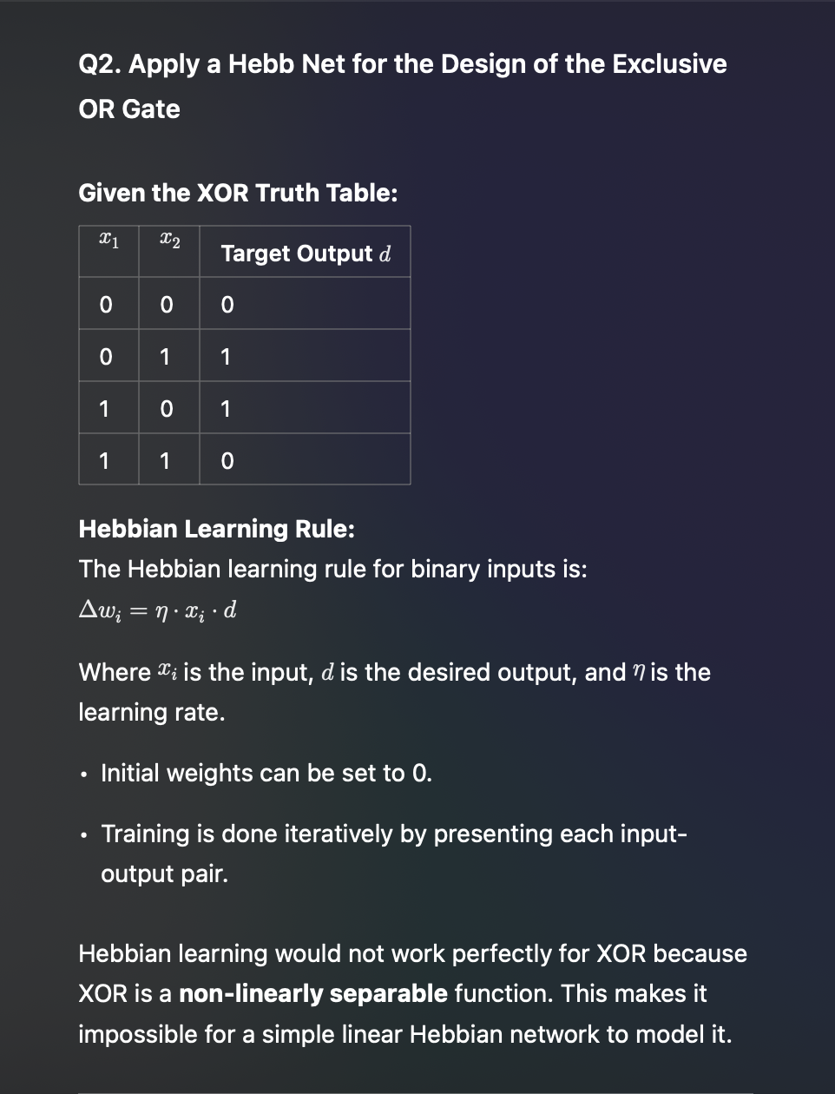

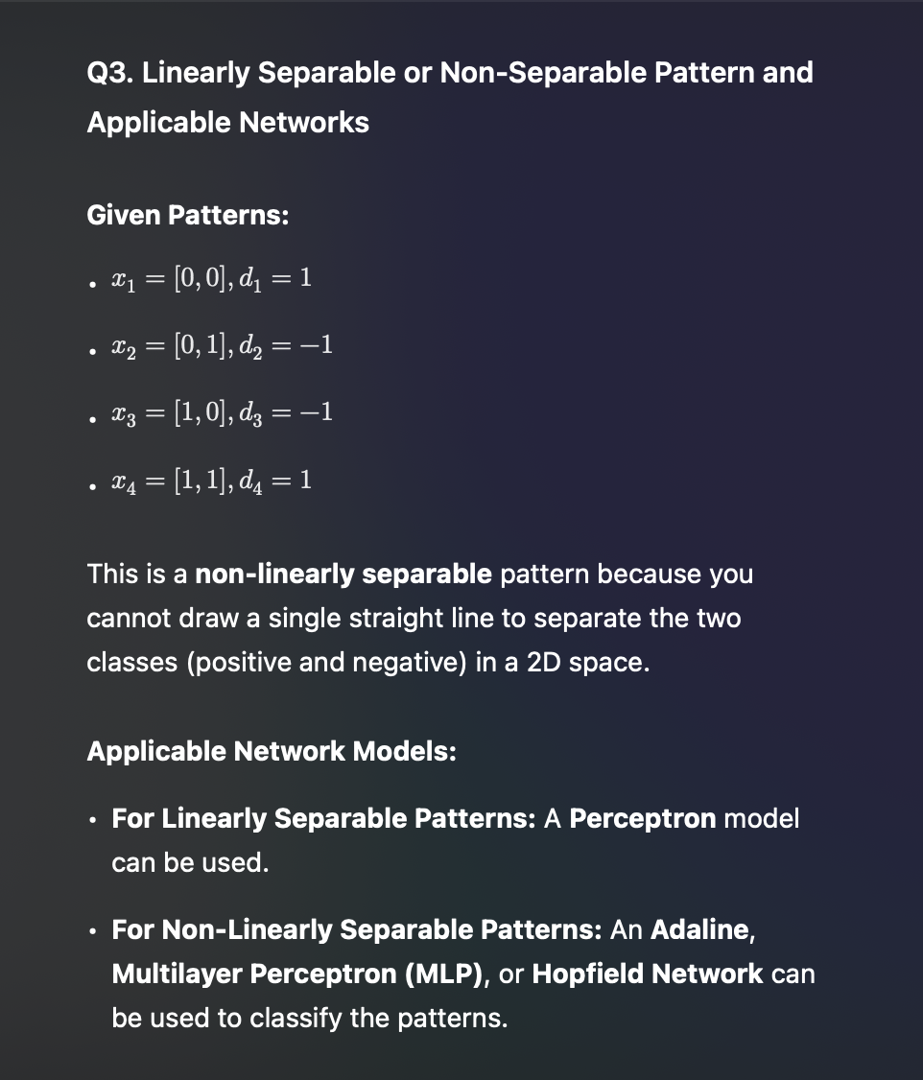

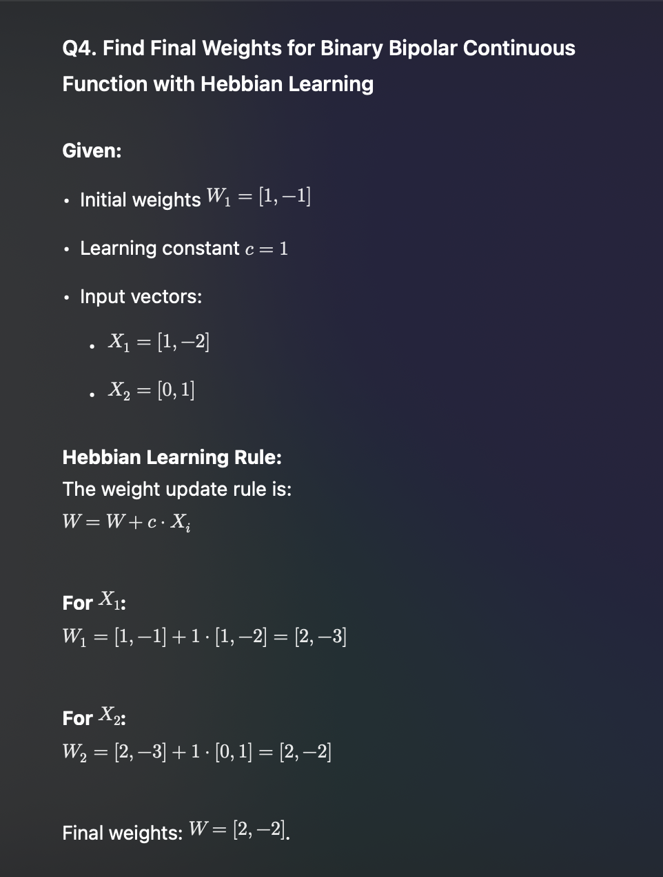

# Unit 3

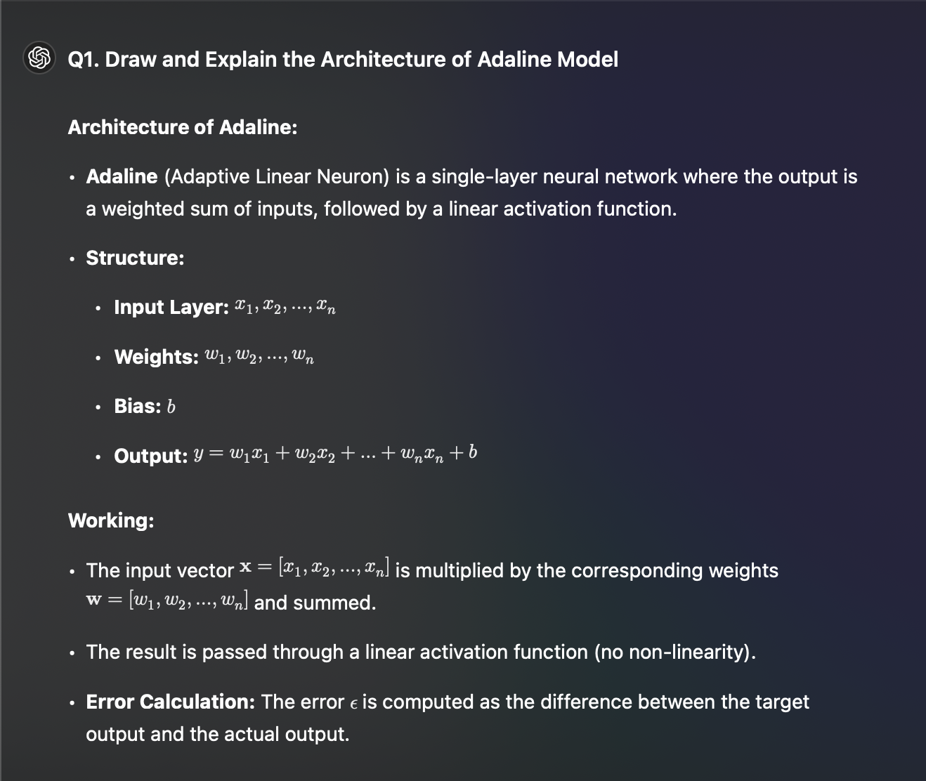

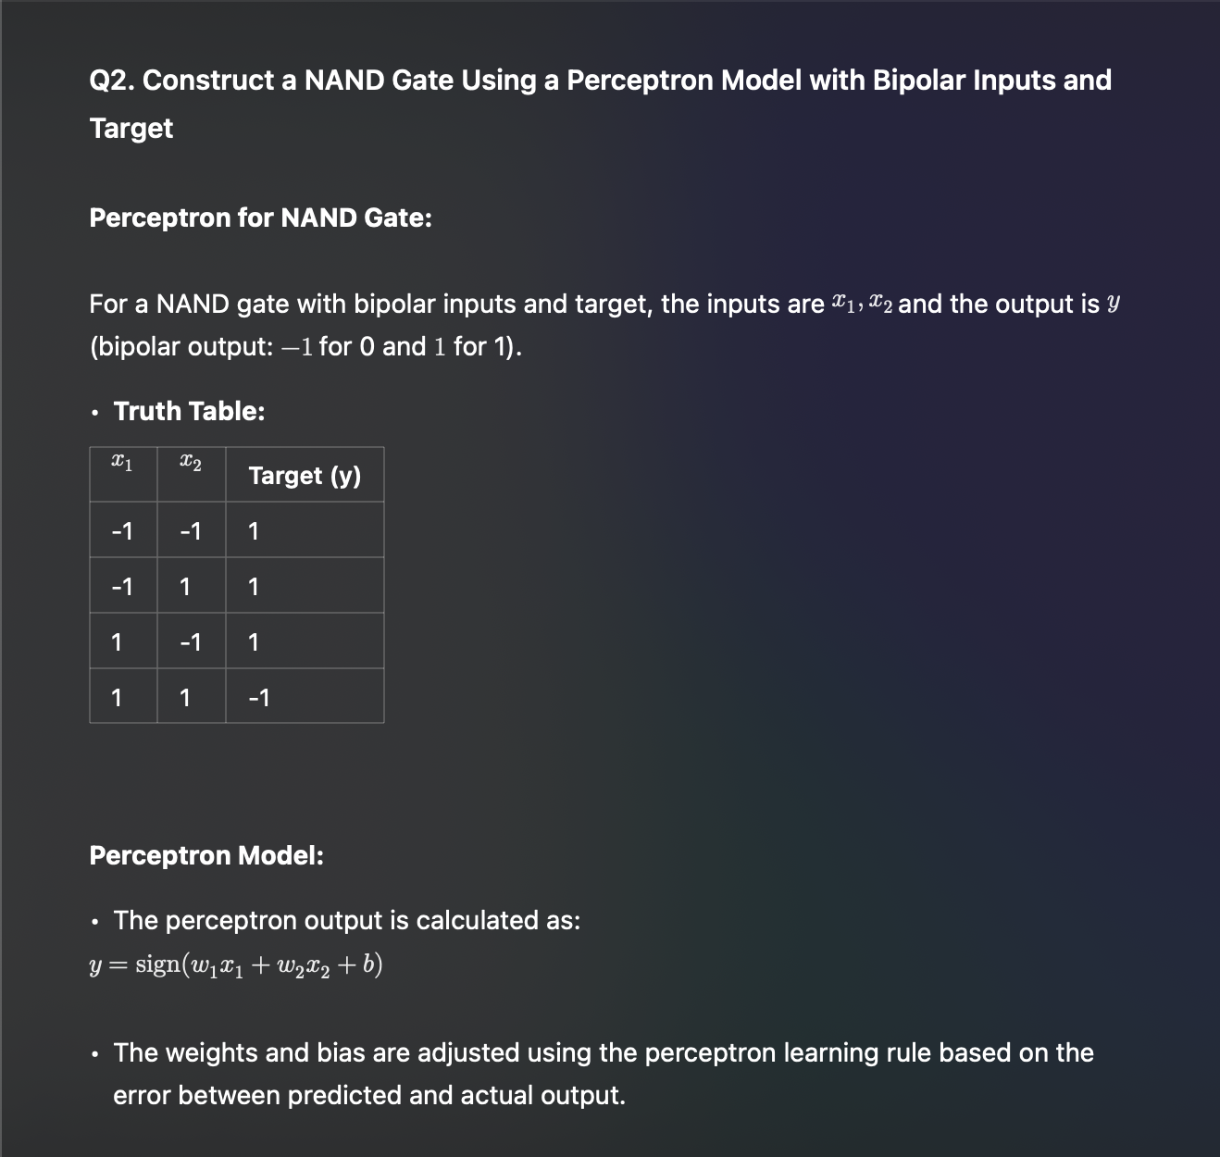

**Q.3 Construct a OR gate using the Adaline model, assume initial weights wl=0.1, w2=0.2, b=0.2, learning rate =0.5. Solve for two epochs.**

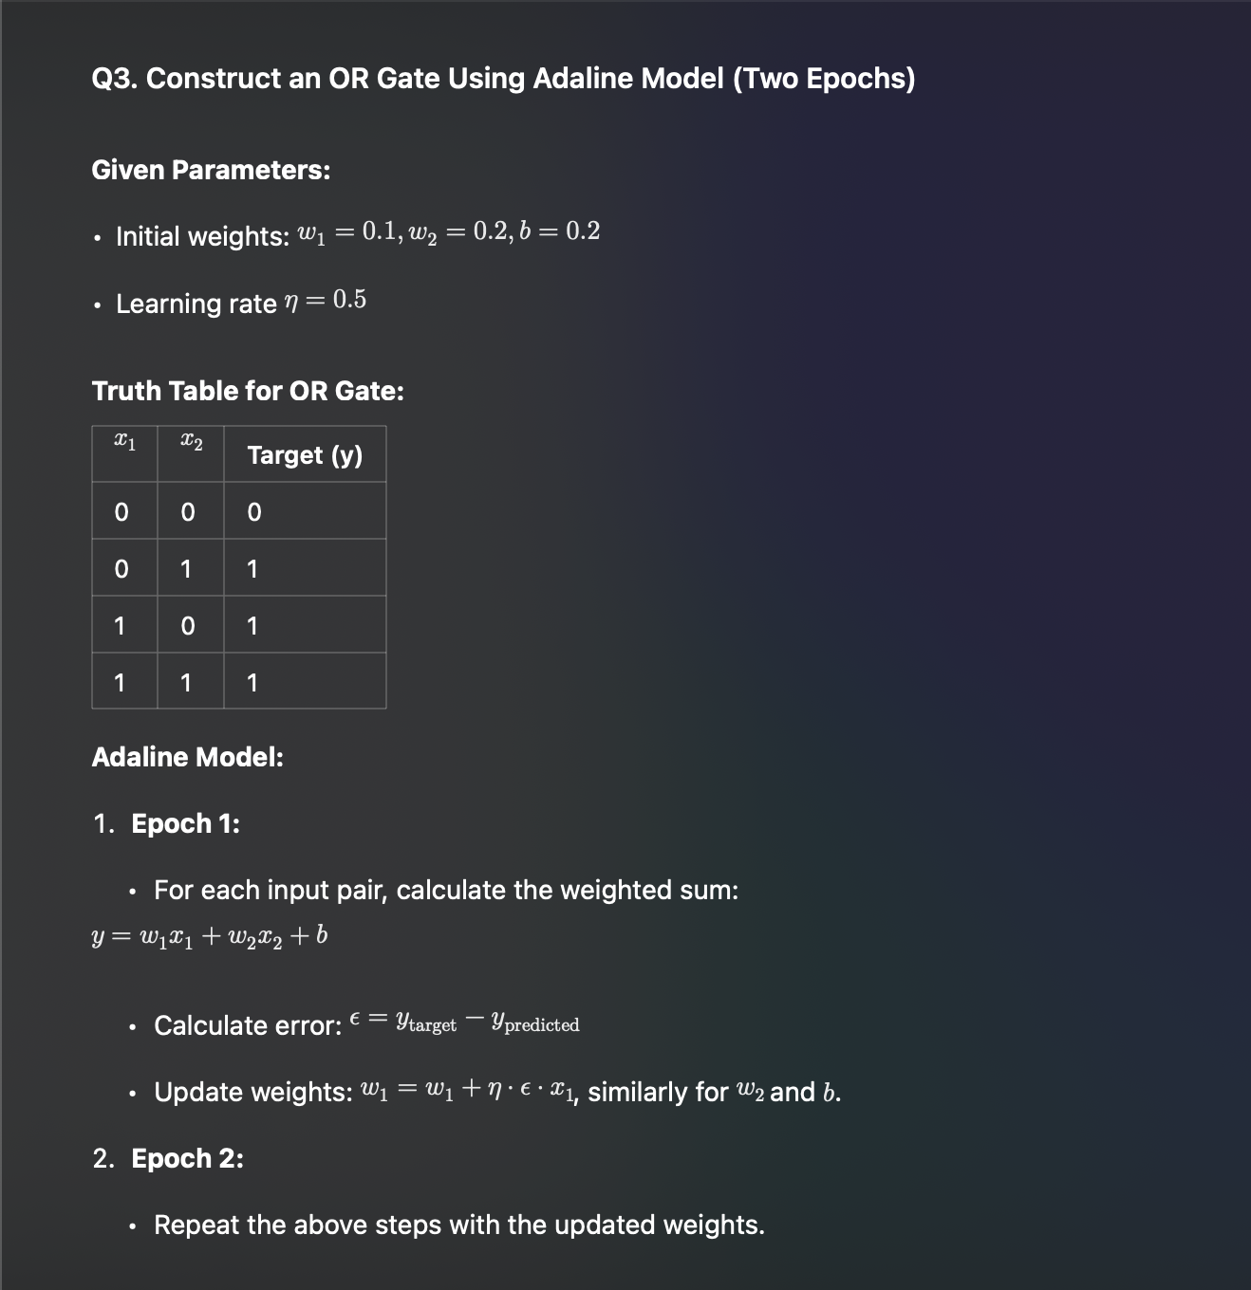

**Q5. Perform two training step of the network using delta learning rule. The parameters are lambda = 1 and learning constant = 0.25. Given data pair is (X1= [2 0-1]T, di = -1), (X2= [1 -2 -1] T, d2 = 1), Initial weights are W, = [1 0 1] '. Use unipolar continuous function.**

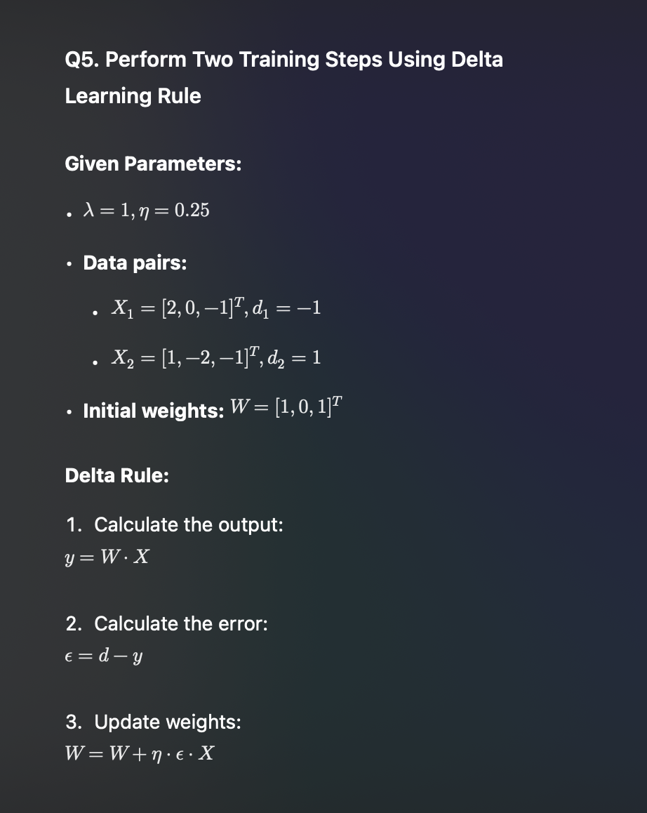

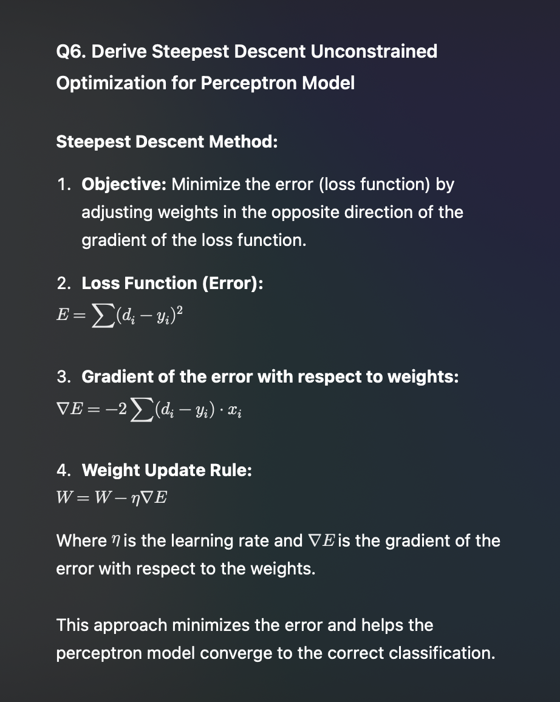

# Unit 4

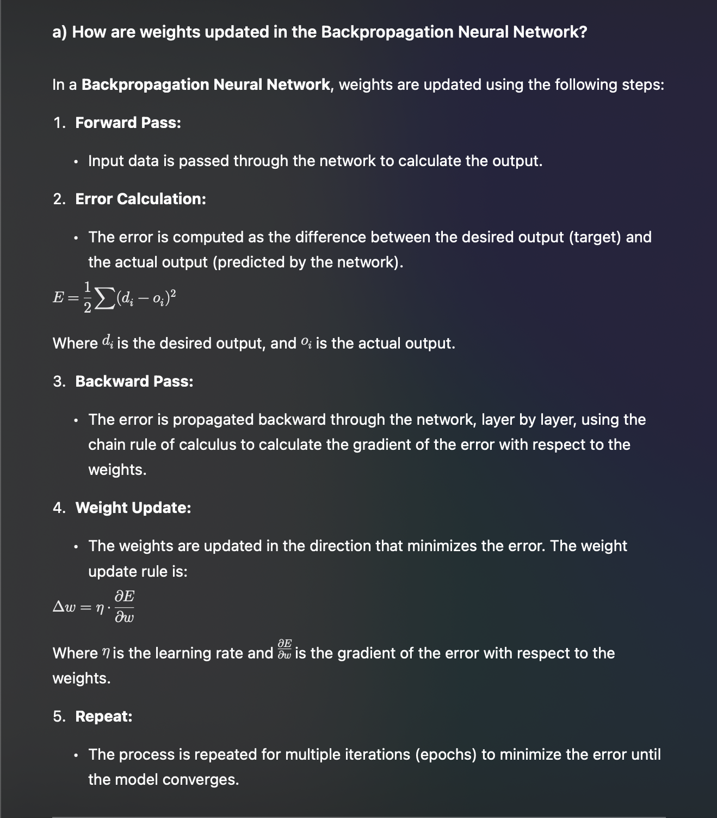

**Q2. What are Convolutional Networks? Explain in Detail.**

**Convolutional Neural Networks (CNNs)** are specialized deep learning models primarily used for image processing and recognition tasks. CNNs are designed to process grid-like data, such as images, by using the following key components:

1. **Convolutional Layer:**

• This layer applies convolution operations on the input to create feature maps. Convolution filters (kernels) slide over the input data and perform element-wise multiplication, capturing spatial hierarchies.

2. **Activation Layer (ReLU):**

• After the convolution, an activation function (usually ReLU) is applied to introduce non-linearity into the network.

3. **Pooling Layer:**

• Pooling operations (like max pooling or average pooling) reduce the dimensionality of the feature maps, making the model more computationally efficient and invariant to small translations.

4. **Fully Connected Layer:**

• After several convolutional and pooling layers, the network flattens the output and passes it through a fully connected layer to make predictions.

5. **Softmax Layer:**

• For classification tasks, a softmax layer is applied at the end to convert the network’s output into class probabilities.

**Applications of CNNs:**

• Image classification, facial recognition, object detection, etc.

Construct and draw a network for the given description of the problem statement. The network is presented the input pattern [1 2 - 1]. Use bipolar continuous activation function. Learning rate is 1, lambda 1. Target output is [0.95 0.05], Weight for hidden layer is V=[1 -2 3; 2 0-1], weights for input layer is W=[1 0 2; 1 -2 3].

**Q3. Construct and Draw a Network for the Given Problem Statement**

• **Problem:** Input Pattern = [1 2 -1]

• Target Output = [0.95, 0.05]

• **Weight Matrices:**

• Weight for hidden layer V = \begin{bmatrix} 1 & -2 & 3 \\ 2 & 0 & -1 \end{bmatrix}

• Weights for input layer W = \begin{bmatrix} 1 & 0 & 2 \\ 1 & -2 & 3 \end{bmatrix}

• **Activation Function:** Bipolar continuous.

• **Learning Rate (η):** 1

• **Lambda (λ):** 1

**Q4. Elaborate which two signals are propagated in error back propagation algorithm. Draw flowchart of the error back propagation algorithm.**

The two main signals propagated during the **error backpropagation algorithm** are:

1. **Error Signal (δ):** This is the difference between the target output and the actual output, passed back through the network.

2. **Gradient (∇):** This signal represents the rate of change of the error with respect to the weights and is used to update the weights.

A simplified flowchart for the **Error Backpropagation Algorithm**:

Start

↓

Initialize weights and biases

↓

For each training sample:

↓

Forward Pass

↓

Calculate error (E) at output layer

↓

Backward Pass (Compute error gradients)

↓

Update weights and biases (using gradient descent)

↓

Repeat for next training sample

↓

If error is minimized or max epochs reached, stop

↓

End

# Unit 5

**Q1. Define hamming distance. Explain how hamming net can be used as a maximum likelihood classifier network?**

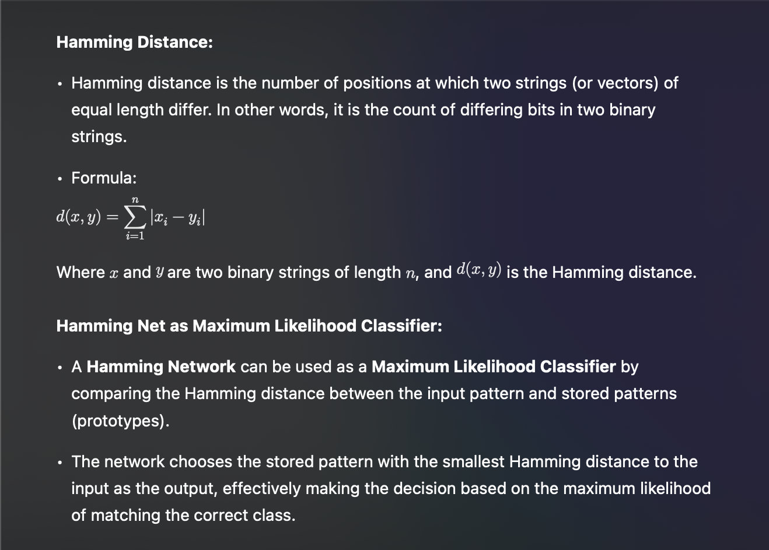

**Q2. Draw the architecture of the discrete Hopfield net and explain its working. What is the convergence of Hopfield model?**

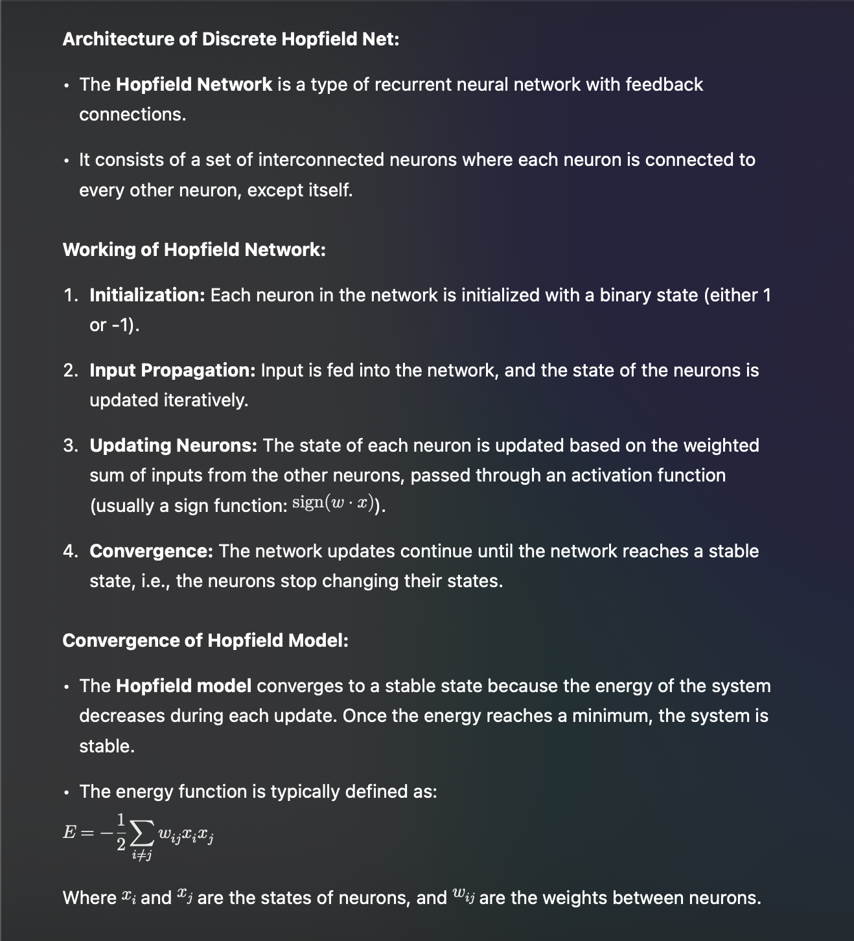

**Q4. Train Autoassociative Network for Input [-1 1 1 1] and Test with One Missing Entry**

